WorldCALL2023 Conference Proceedings Submission Guidelines

Please format your Conference Proceedings paper according to the following guidelines, style checklist and paper template, and submit it through the Online Submission System. Papers that do not follow these guidelines will be returned for editing.

Article structure

Please use the article structure outlined below.

Title

Ensure that your title accurately reflects the contents of your paper and is free of errors.

Abstract

A concise and factual abstract is required (maximum length of 350 words). The abstract should state briefly the purpose of the research, the principal results and major conclusions. An abstract is often presented separately from the article, so it must be able to stand alone. For this reason, references should be avoided, but if essential, then cite the author(s) and year(s). Also, non-standard or uncommon abbreviations should be avoided, but if essential they must be defined at their first mention in the abstract itself.

Keywords

Immediately after the abstract, provide a minimum of three keywords.

Introduction

Present the purposes of the study and provide background for your work.

Conclusions

The main conclusions of the study may be presented in a Conclusions section, which may include the main findings, the implications and limitations.

Acknowledgements

Collate any acknowledgements in a separate section at the end of the article before the references and do not, therefore, include them on the title page, as a footnote to the title or otherwise. List here those individuals who provided help during the research (e.g., providing language help, writing assistance or proofreading the article, etc.).

Footnotes

Footnotes should be used sparingly. Number them consecutively throughout the article, using superscript Arabic numbers.
References

In-text citations
Please ensure that every reference cited in the text is also present in the reference list (and vice versa).

Reference style
Within the text: citations in the text should follow the referencing style used by the American
Psychological Association (APA). Publication Manual of the American Psychological
Association, Sixth Edition, ISBN 978-1-4338-0561-5.

List at end of paper: References should be arranged first alphabetically and then further sorted chronologically if necessary. Please single space, and indent after the first line of each.

Reference to a journal publication:
Van der Geer, J., Hanraads, J. A. J., & Lupton, R. A. (2010). The art of writing a
scientific article. Journal of Scientific Communications, 163, 51–59.

Reference to a book:
Strunk, W., Jr., & White, E. B. (2000). The elements of style. (4th ed.). New York:
Longman.

Reference to a chapter in an edited book:
Mettam, G. R., & Adams, L. B. (2009). How to prepare an electronic version of your
article. In B. S. Jones, & R. Z. Smith (Eds.), Introduction to the electronic age (pp. 281–304). New York: E-Publishing Inc.

Resources

“Rules of Thumb for Writing Research Articles” by Tomislav Hengl and Michael Gould: http://thesishub.org/rules-of-thumb-for-writing-research-articles

Style checklist:

- APA Style – http://bit.ly/APAguide

- 12-point Times New Roman font.

- All paragraphs and body text justified and single spaced.

- One line should separate paragraphs or sections. Do not indent paragraphs.

- Set page size to A4.

- Margins: Microsoft Word ‘Normal’ (2.54 cm).

- Manuscripts not to exceed 2,500 words each (excluding tables, figures and references). Manuscripts longer than 2,500 words will be returned for editing.

- Main headings, subheadings and sub-subheadings should be formatted as in the example below. No more than three levels of headings should be included.

- All figures and images must be inserted in a JPEG image format, within the page margins. Centre images. Do not insert loose objects such as arrows, lines or text boxes. Number and caption below the figure (Figure 1: Caption), centre aligned.

- Tables should be created within the Microsoft Word document, should fit onto one A4 page and should be numbered and captioned below the table, centre aligned.

- Bold any section/paragraph headers and left align.

- Do not use any page headers, footers or page numbers (footnotes are acceptable).

- Use only portrait layout. Do not include any pages in landscape layout.

- Corresponding author contact email address may be added to the end of the paper after references. IAFOR is not responsible for unsolicited emails received.

- An optional Acknowledgments (max. 150 words) may be included as the last section before reference list.

- Title page information to include:
  - Title of the paper
  - Author names and affiliations: Provide authors' affiliation details (where the work was done) including full institution name and country.
  - Abstract: A concise and factual abstract not exceeding 250 words is required.
  - Keywords: Immediately following the abstract provide a minimum of three keywords.

Title of Paper

Author, Name of University/Organisation, Country
Author, Name of University, Country (if applicable – max 5 authors)

WorldCALL2023
Official Conference Proceedings

Abstract (Maximum of 350 Words)
Lorem ipsum dolor sit amet, consectetur adipisicing elit, sed do eiusmod tempor incididunt ut labore et dolore magna aliqua. Ut enim ad minim veniam, quis nostrud exercitation ullamco laboris nisi ut aliquip ex ea commodo consequat. Duis aute irure dolor in reprehenderit in voluptate velit esse cillum dolore eu fugiat nulla pariatur.

Excepteur sint occaecat cupidatat non proident, sunt in culpa qui officia deserunt mollit anim id est laborum. Lorem ipsum dolor sit amet, consectetur adipisicing elit, sed do eiusmod tempor incididunt ut labore et dolore magna aliqua. Ut enim ad minim veniam, quis nostrud exercitation ullamco laboris nisi ut aliquip ex ea commodo consequat. Duis aute irure dolor in reprehenderit in voluptate velit esse cillum dolore eu fugiat nulla pariatur. Excepteur sint occaecat cupidatat non proident, sunt in culpa qui officia deserunt mollit anim id est laborum.

Keywords: (minimum of 3)

Introduction

Lorem ipsum dolor sit amet, consectetur adipisicing elit, sed do eiusmod tempor incididunt ut labore et dolore magna aliqua. Ut enim ad minim veniam, quis nostrud exercitation ullamco laboris nisi ut aliquip ex ea commodo consequat. Duis aute irure dolor in reprehenderit in voluptate velit esse cillum dolore eu fugiat nulla pariatur.

Excepteur sint occaecat cupidatat non proident, sunt in culpa qui officia deserunt mollit anim id est laborum. Lorem ipsum dolor sit amet, consectetur adipisicing elit, sed do eiusmod tempor incididunt ut labore et dolore magna aliqua. Ut enim ad minim veniam, quis nostrud exercitation ullamco laboris nisi ut aliquip ex ea commodo consequat. Duis aute irure dolor in reprehenderit in voluptate velit esse cillum dolore eu fugiat nulla pariatur. Excepteur sint occaecat cupidatat non proident, sunt in culpa qui officia deserunt mollit anim id est laborum.

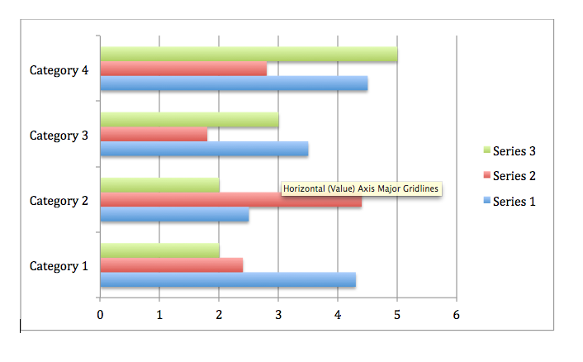
Figure 1: This is an image.

Conclusion

Lorem ipsum dolor sit amet, consectetur adipisicing elit, sed do eiusmod tempor incididunt ut labore et dolore magna aliqua. Ut enim ad minim veniam, quis nostrud exercitation ullamco laboris nisi ut aliquip ex ea commodo consequat. Duis aute irure dolor in reprehenderit in voluptate velit esse cillum dolore eu fugiat nulla pariatur. Excepteur sint occaecat cupidatat non proident, sunt in culpa qui officia deserunt mollit anim id est laborum. Lorem ipsum dolor sit amet, consectetur adipisicing elit, sed do eiusmod tempor incididunt ut labore et dolore magna aliqua. Ut enim ad minim veniam, quis nostrud exercitation ullamco laboris nisi ut aliquip ex ea commodo consequat. Duis aute irure dolor in reprehenderit in voluptate velit esse cillum dolore eu fugiat nulla pariatur. Excepteur sint occaecat cupidatat non proident, sunt in culpa qui officia deserunt mollit anim id est laborum.

[Referencing / Bibliography to start on a new page – Please delete]
References

Cameron, D. (2001). Working with spoken discourse. London: SAGE.

Coates, J. (2007). Talk in a play frame: More on laughter and intimacy. Journal of Pragmatics, 39, 29-49.

Drew P., & Heritage J. (1992). Analysing talk at work: An introduction. In P. Drew, & J. Heritage (Eds.), Talk at work (pp. 3-65). Cambridge: Cambridge University Press.

Contact email: example@iafor.edu (optional)

